The One With The Mugging

915 打劫
在竞演某舞台剧主角的试镜中，Joey为打动某著名演员兼导演，尝试了不同寻常的“内急法”。
Ross和Phoebe同在街上遭遇打劫，结果Ross发现童年时抢劫他原创漫画《科学男孩》的真凶。
Chandler到广告公司实习，一同实习的年轻人使他感觉自己像个老妖怪。
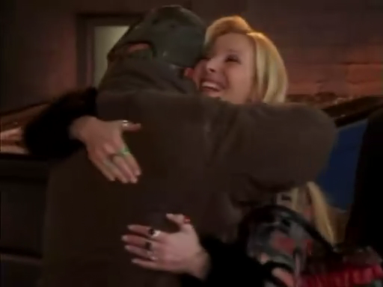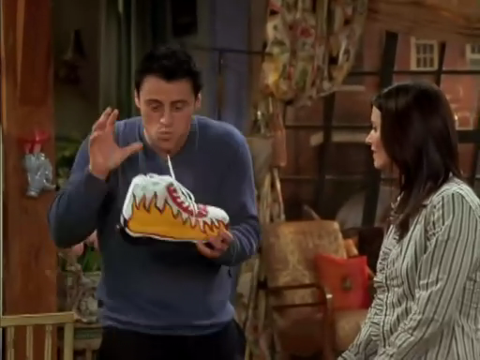
9.15 The One With The Mugging
Chandler gets an internship in advertising.
At first his age seems to be a problem, relative to(adv.相对于) all the young college kids.
But his age and experience gives him a perspective that serves him well, even in marketing products to teenagers.
Joey gets a audition for a broadway play;
at first he's terrible, but later (when he really needs to go to the bathroom) his nervous energy impresses the producers and star, and he gets the part.
Phoebe and Ross get mugged, but it turns out Phoebe knows the mugger from her days on the streets, when she occasionally mugged people, too.
This reminds Ross of the time he was mugged as a child;
Phoebe realizes she was the one who mugged him all those years ago.
He's very upset about it, until she returns his childhood home-made(adj.自制的) comic book, "Science Boy."

[Scene: Central Perk, Joey, Ross, Monica and Phoebe are there as Chandler enters]
Chandler: (excited) Guys, guys, I've got great news! Guess what...
Joey: Uh, ah, Monica's pregnant?!
Monica: (shocked) Really? (She looks around, suddenly embarrassed) Let's get past the moment.
Let's get past the moment当我没说
Phoebe: What's your news?
Chandler: Thank you. I got a job in advertising. (Everybody cheers)
Monica: (hugging Chandler) Oh, honey, that's incredible!
Phoebe: (inquisitive) Gosh, what's the pay like? (Everybody stares at her indignantly) Oh, come on people...(defending) come on, now, if I don't know who makes the most, how do I know who I like the most! (She looks at Joey) Hey Joey! (Joey winks at her)

inquisitive adj.好问的 好奇的[eg: The child has an inquisitive mind]/indignantly adv.愤怒地
Chandler: Actually, it pays nothing. It's an internship.
internship n.实习
Joey: Oh, that's cool. We have interns at 'Days Of Our Lives'.
intern n.实习医师
Chandler: Right. So, it'll be the same except...less sex with you. (Joey nods)
Ross: So, uh, what kinda stuff do you think they'll have you do there?
Chandler: Well, it's a training program, but at the end, they hire the people they like.
training program n.培训计划
Phoebe: (enthusiastic) That's great.
Chandler: Yeah, I mean, there's probably gonna be some ground work which will probably stink, you know, grown man getting people coffee is a little humiliating.
ground work n.底层工作/stink<俚>suck
(At the same time, Gunther puts down a cup of coffee in front of Chandler)
Chandler: (grinning awkwardly) Humiliating and noble! Thank you!
grin v.露齿而笑
(Gunther shoots a nasty look at him while leaving)
Ross: You know, if I didn't already have a job, I think, I would have been really good in advertising.
Monica: Ross, you did not come up with "got milk?"
come up with v.提出
Ross: Yes, I did, I did! (He turns to Joey, disappointed) I should have written it down!
Opening Credits
[Scene: Monica and Chandler's Aparment, Monica sits at the table]
Joey: (entering) Hey!
Monica: Hey!
Joey: Where's Chandler? I wanna wish him good luck on his first day. (Monica smiles) .. and I smelled bacon. (taking some)
bacon n.熏猪肉 咸猪肉[eg: We had bacon and eggs for breakfast]
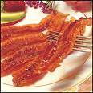
Monica: He just left.
Joey: (puzzled) Who did? (Monica looks bewildered)
bewildered adj.困惑的
Rachel: (entering) Joey! You never gonna believe it: she called.
Joey: (standing up, surprised) She did?
Rachel: (enthusiastic) You got it!
Joey: (still surprised) I did?
Monica: What is she talking about?
Joey: I don't know, but it sounds great.
Rachel: Your agent called. You got that audition.
Joey: With Leonard Hayes?
Rachel: Yes.
Joey: Oh my god, that is great! That is for a play on broadway...and in a real theatre, not that little one underneath the deli like last time.

deli n.<美>熟食店/Broadway theatre is the most well known form of professional theatre to the American general public and most lucrative(adj.有利可图的) for the performers, technicians and others involved in putting on the shows. Along with London's West End(n.伦敦西区) theatre, Broadway theatre is usually considered to represent the highest level of commercial theatre in the English-speaking world.Broadway theatre, or a Broadway show, refers to a performance, usually a play or musical presented in one of the thirty-nine large professional theatres with 500 seats or more located in the Theatre District of the New York City borough of Manhattan.The shows that reach Broadway and thrive there have historically been perceived as more mainstream and less cutting edge than those produced Off- and Off-Off-Broadway or in regional non-profit theatres such as the Cleveland Playhouse in Cleveland, the Guthrie Theatre in Minneapolis and the American Repertory Theatre in Cambridge, Massachusetts.
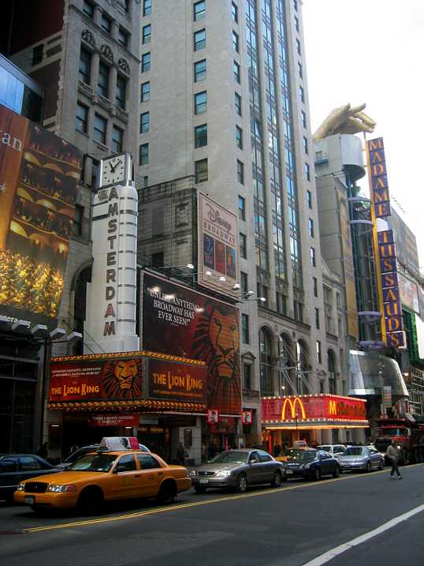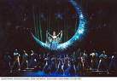
Monica: Is it a good play?
Joey: Well, it must be, because I read and I didn't understand a single word.
Rachel: Yeah, and Leonard Hayes is starring in it...
Joey: Yeah, yeah, and directing.
Monica: (sighs) He was so good in that movie of MacBeth.
Macbeth is among the best known of William Shakespeare's plays, as well as his shortest surviving tragedy. It is frequently performed at professional and community theatres around the world. The play, loosely based upon the historical account of King Macbeth of Scotland by Raphael Holinshed and the Scottish philosopher(n.哲人) Hector Boece,is often seen as an archetypal(adj.原型的) tale of the dangers of the lust for power(渴望争夺权利) and betrayal of friends. It has frequently been adapted. In the theatrical world, many superstitions are associated with "Macbeth," all connected with the belief that the play is somehow "cursed." Many actors will not mention the name of the play aloud, referring to it as "the Scottish Play".
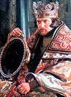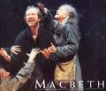
Rachel: (disbelieving) You saw that?
Monica: No, but...I saw the previews. They played it right before Jackass.
preview n.预告片
Rachel and Joey: (pointing at Monica, a look of recognition in their faces) Ah!
recoginition n.承认 赞同
Joey: Yeah, he's done some amazing works.
Rachel: Oh, yeah. Oh, I loved him in those cell phone commercials.
Joey: (almost laughing) I know. When the monkey hits him in the face with that giant rubber phone. (They all laugh)
Monica: Hey! Maybe the monkey will be at the audition!
Joey: (sitting down) Don't make me more nervous than I already am!
[Scene: Chandler's new workplace, his fellow interns are already seated around a table]
Chandler: (entering) Good morning, everybody.
Intern: Can I get you a cup of coffee, Sir?
Chandler: Oh, no, no, I'm an intern, just like you guys...except for the tie, the briefcase...and the fact that I can rent a car.

intern n.实习生
Intern: Seriously, you're an intern?
Chandler: Yeah, well, I'm kinda heading into a new career direction and, you know, you gotta start at the bottom.
Intern: (shaking his head disbelievingly) Dude!
disbelievingly adv.怀疑地 不相信地
Chandler: Right. Look, I know I'm a little bit older than you guys, but it's not like I'm Bob Hope (he sits down)
Bob Hope (May 29 1903 – July 27 2003), was an English-born American entertainer who appeared in vaudeville(n.歌舞杂耍表演), on Broadway, on radio and television, in movies, and in performing tours for U.S. Military personnel. He was well known for his good natured humor and the longevity of his career.
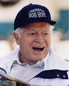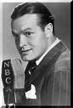
(Everybody gives him an inquiring look)
inquiring adj.打听的 怀疑的
Chandler: The comedian? USO?!
comedian n.喜剧演员/The United Service Organizations Inc.(USO) is a private, nonprofit organization that provides morale and recreational services to members of the U.S. military worldwide(美国)劳军联合组织

/ Hope performed his first United Service Organizations (USO) show on May 6 1941, at March Field, California. He continued to travel and entertain troops for the rest of World War II and later during the Korean War, the Vietnam War and the 1990–1991 Persian Gulf War. When overseas he almost always performed in Army fatigues(<军>杂役) as a show of support for his audience. Hope's USO career lasted half a century, during which he headlined(v.当主角) approximately sixty tours. For his service to his country through the USO, Hope was awarded the prestigious Sylvanus Thayer Award by the United States Military Academy at West Point in 1968. Of Hope's USO shows in World War II, writer John Steinbeck, who was then working as a war correspondent, wrote in 1943: When the time for recognition of service to the nation in wartime comes to be considered, Bob Hope should be high on the list. This man drives himself and is driven. It is impossible to see how he can do so much, can cover so much ground, can work so hard, and can be so effective. He works month after month at a pace that would kill most people.A 1997 act of Congress signed by President Clinton named Hope an "Honorary Veteran". He remarked, "I've been given many awards in my lifetime — but to be numbered among the men and women I admire most — is the greatest honor I have ever received."However, there were also critical voices relating to the entertainer's patriotic activities. In his biography, Bob Hope: The Road Well-Traveled (1999), Lawrence J. Quirk writes that Hope was making sacrifices to entertain U.S. servicemen, whom he called "my boys".
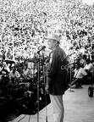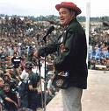
Intern: (correcting him) Uhm, it's USA, sir.
(Chandler desperately covers his head in his hands)
[Scene: Audition room, Joey is lead into the room by a receptionist in a fancy dress]
Receptionist: This is Joey Tribbiani. Joey, these are the producers and as you probably already know, this is Leonard Hayes.
Jeffrey Lynn Goldblum (born October 22, 1952) is an Academy-Award nominated American actor. He often portrays quirky(adj.古怪的), intense or eccentric characters. He is also known for his distinctive appearance and his unique, staccato(n.断唱) delivery[n.演讲(或唱歌)的姿态风格] of lines. At 6 feet 4 ½ inches (1.94 m), he is amongst Hollywood's tallest actors.

(Lennart Haze turns around in his chair to face Joey)
Joey: It is so amazing to meet you. (They are shaking hands) I'm such a big fan of your work.
Lennart: Well, I've...I've been blessed with a...a lot of great roles.
be blessed with <口>在...方面有福气 幸运地享有
Joey: Tell me about it! "Unlimited nights and weekends!"
unlimited adj.无限的
Lennart: Are you making fun of me? Because I am not a sellout. (He stands up and walks menacingly towards Joey) I didn't do that for the money, I believe in those phones. I almost lost a cousin because of bad wireless service.
make fun of v.取笑/sellout n.An event for which all the tickets are sold卖座的人(或事)/menacingly adv.威吓地
Joey: No, I-I-I wasn't making fun of you, honestly, I-I think you were great in those commercials.
Lennart: Really?
Joey: Yeah.
Lennart: Well, I do bring a certain credibility to the role.
credibility n.可信性 确实性
Joey: (regaining confidence) Are you kiddin'? When they shoot you out of that cannon...
cannon n.加农炮
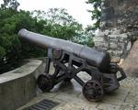
Lennart: Peeeeeooooooooch (He mimes flying out of the cannon) "Hang up that phone!" One take!
mime v.模仿
Joey: Wow!
Lennart: So, shall we read?
Joey: Oh, yeah, sure.
Lennart: Top of act two. This is my entrance. You got it?
entrance n.进入
(Joey nods whereupon Lennart acts as if he is entering a room)
whereupon adv.于是 随之[eg: They got into a quarrel, whereupon she left him]
Lennart: "What the hell are you still doing here"?
(Joey stares at him, fascinated by his performance)
Joey: Err, "I think you know".
Lennart: "Bastard"!
Joey: "I am what you made me. You know what? I could go right now."
Lennart: "Go, go!"
Joey: "I can't. Oh, I want to, long pause, but I can't."
Lennart: I'm sorry, sorry. You're not supposed to say "long pause"
Joey: (understandingly) Oh, oh, I thought that was your character's name, you know, I thought you were like an Indian or something, you know with a...(He mimes wearing a feather on his head)

understandingly adv.领悟地/mime doing sth 模仿做某事
Lennart: No. Thank you so much for coming in. We appreciate it, thank you.
Joey: Ah, y-y-you're sure you don't want me to do it again? I could do it with an accent, you know, Southern (He speaks in what he believes is a Southern accent) "I could go right now, maaan!"
Lennart: (stunned, muttering) My god in heaven.
mutter v.咕哝
(The producers stand up)
Producer #1: Joey, hang on for a second. Lennart, can we talk to you for a moment?
(They stand aside, talking)
stand aside v.站在一边
Lennart: You, you gotta be kidding. See, h-he, he can't act. (Joey hears that and his disappointment is reflected in his facial expression).
facial expression n.面部表情
(Producer #1 whispers something)
Lennart: Hey! I-I-I don't care if he's hot, you know. If you wanna sleep with him, do it on your own time. (Joey smiles smugly at this) This is a play. No, listen: if you insist on this, I will call my agent so fast on a cell phone that has a connection that is so clear he's gonna think I'm next door.

smugly adv.自鸣得意地
(Joey approaches them)
Joey: (interrupting their conversation) Ah, hi, ah. Thank you so much for whispering for my benefit, but, ah, look, if you just tell me what I did wrong, I'd just love to work on it and come back and try it again for you. And, and also: (to Producer #1) 'How you doing?' (to Lennart again) You should, please, just give me another chance. I really wanna get better, please.

whisper for one's benefit 为我说好话
Lennart: Well, if you wanna come back at the end of the day today, here are my notes. Ready?
at the end of the day adv.到最后 在结束的时候/note n.建议
Joey: Yeah.
Lennart: Uhm, you're in your head. You-you're thinking way too much.
Joey: I really doubt that.
Lennart: (explaining to Joey, who nods fervently.) No, no, no. It's that you're not connected with anything in your body. There's no urgency. The scene is a struggle, uhm, it's a race. Also, what you did was horizontal. Don't be afraid to explore the vertical. And don't learn the words. Let the words learn you.

fervently adv.热情地 热烈地[eg: "Oh, I am glad!" she said fervently]/urgency n.紧急/struggle n.奋斗 斗争[eg: The struggle between the two teams was hard]/horizontal adj.水平的/vertical adj.垂直的
(Joey ponders on this for a while)
ponder on sth 对某事沉思
Joey: (suggesting.) Couldn't I just sleep with the producer?
Lennart: I'm gonna blow.(break the pencil)Blow
blos<俚>to leave (突然或匆忙)离去
[Scene: Backstreet, Ross and Phoebe walking]
Phoebe: Hey, do you wanna go to dinner tonight?
Ross: Oh, I can't. I've got a date with that waitress, Katy. Yeah, I know we've only gone out like twice, but I don't know.I have a really good feeling about her.
Phoebe: Oh, I hear divorce bells.
(A mugger, his face hidden by a cap, approaches them from behind)
mugger n.<俚>偷袭抢劫者;强盗
Mugger: Alright. Just give me your wallets and there won't be a problem.
Ross: (taken aback) What?
be taken aback 是一条为英美人普遍使用的习惯用语。此语意指 大吃一惊 吓了一跳[eg1:He was taken aback at the news that Lili had been copped out][eg2:The manager was taken aback at the news that some company had already launched the product into the market]
Mugger: I have a gun (It looks like he has a gun under his coat)
Ross: O-ok. Just relax, Phoene, just stay calm. (He searches his coat and freaks out). Oh my god, I can't find my wallet.
(He finally finds the wallet and hands it to the mugger)
Mugger: Alright, lady, now give me your purse!
Phoebe: No.
Ross: (still in a high-pitched voice) What do you mean "no"? I knew you'd be my death, Phoebe Buffay.
you'd be my death 死在我手里
(A sign of recognition runs across Phoebe's face)
Phoebe: Lowell, is that you?
Lowell: Phoebe? (He lifts his cap) Oh my god!
Phoebe: (simultaneously) Oh my god! Unbelievable.
(They hug and scream)
Phoebe: (excited) I'm sorry, Ross, this is my old friend Lowell from the streets. Lowell, Ross.
Lowell: Ross, nice to meet you. (He stretches his hand out to him)
stretch one's hand v.伸手
Ross: Yeah, a real pleasure.
Phoebe: Ah, it's been so long, so long. (They hug again) I can't believe you're still doing this!
Lowell: Oh, I know, but I quit smoking!
Phoebe: Good for you!
Lowell: So you look like you're doing really well! I guess your mugging days are behind you?
be behind sb 某事对某人来说已成往事
Phoebe: Uh-huh.(she nods)
Ross: (shocked) Oh my god. Phoebe, you used to mug people?
mug<俚>拗分 自背后袭击并抢劫[eg: While walking along a side street, Dick was mugged by two youths]
Phoebe: Excuse me, Ross, old friends catching up...
[Scene: Monica and Chandler's Apartment, Monica sits on the couch as Joey enters]
Joey：Hey.
Monica: Hey, how did the audition go?
Joey: Well, they wanna see me again this afternoon, but, err, well, Leonard Hayes did not like me. (He sits down)
Monica: What happened?
Joey: Well, he said I wasn't urgent enough, you know, and that everything I did was horizontal(simultaneously do the vertical gesture) and I should be more vertical(simutalneously do the horizontal gesture) Oh, and he said that I should think less.
Monica: So far so good! (Joey nods)
So far so good 到目前为止还都不错。
Chandler: (entering, carrying a large box) Honey, I'm old!
Monica: I didn't know you were coming home for lunch. Can I get you anything?
Chandler: Sure, a tube of Polident? Some Depends? Birthday wishes from Willard Scott
tube n.管/ Depend is a brand name for a type of adult-sized diapers marketed to those afflicted with urinary(adj.尿的) or fecal(adj.排泄物的) incontinence(<医>失禁). It was invented by Bob Beaudrie(AKA "The Bear"). The Depend brand was introduced in 1980; television commercials with actress June Allyson first spotlighted the Depend brand, with Allyson urging adults with incontinence issues to "Get back into life!"

Willard Herman Scott, Jr. (born March 7, 1934) is an American media personality and author best known for his work on NBC's Today show and as the original creator of Ronald McDonald.Born in Alexandria, Virginia, Scott attended American University in Washington, D.C. and was a member of the Alpha Sigma Phi Fraternity(n.兄弟会). While there, he met Ed Walker. The two hosted a program on the university radio station WAMU-AM for two years, before moving in 1953 to WRC-AM, the NBC owned-and-operated television station in Washington.From 1955 to 1972, Scott teamed with Ed Walker as co-host of the nightly Joy Boys radio program on WRC-AM. Scott would sketch a list of characters and a few lead lines setting up the situation, which Walker would commit to memory(v.把…记牢) or make notes on his Braille(n.盲人用点字法) typewriter(n.打字机), due to his blindness since birth. In a 1999 article recalling the Joy Boys at the height of(adv.在…的高潮中) their popularity in the mid-1960s, the Washington Post said they "dominated Washington, providing entertainment, companionship(n.友谊), and community to a city on the verge of powerful change".The Joy Boys show remained on WRC until 1972 when they moved to cross-town station WWDC for another two years. Of their close professional and personal bond which has continued to the present, Scott wrote in his book, The Joy of Living, that they are "closer than most brothers".
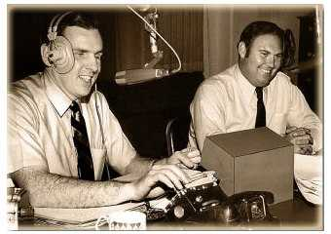

Polident美国保丽净假牙清洁锭(假牙片)

Monica: What's wrong?
Chandler: I am so much older than these other interns. I can't compete with them.
Monica: So you're a little older. Try to look at the positive: You have so much life experience.
Try to look at the positive 看事情好的那面
Chandler: Yes, but I don't think life experience is gonna help me with these. (He opens the box and takes an inline skate like sneaker out)

inline skate n.单排轮/sneaker<口>运动鞋
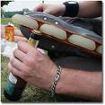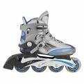
Joey: Wooooooooow (He takes the sneaker) It's like they're on fire!(wince as if it's hot)
Monica: What are they? (They sit down again.)
Chandler: They're these prototype sneakers and come up with ideas on how to sell them which I can't do because no self-respecting adult would ever wear these.

prototype n.原型 样品/self-respecting adj.自重的
Joey: (determined) I'll give you $500 for them!
Chandler: What am I supposed to do with these?
Monica: Ah, come on, sneakers are easy. You wear sneakers all the time.
Chandler: Well, first of all, they're not called "sneakers" anymore. Apparently, they're called "kicks" or "skids" and I think I heard somebody say "slorps". (He takes a sneaker) And here, look: they've got these wheels to pop out from the bottom so you can roll around 'cause, apparently, walking is too much exercise. Kids, kids, roll your way to childhood obesity!

skid n.制轮器 煞车/pop out v.弹出/childhood obesity n.儿童肥胖

Monica: Wow! Kids today have such an easier time getting fat.

Chandler: (to Monica) Would you help me try to sell these?

Monica: Okay, have you considered using a girl with huge knockers?

knocker<俚>A breast

huge knockers

Chandler: No, I don't think that's the kinda thing they're looking for.

Joey: Hey, that'd work on me! Why do you think I buy Mrs. Butterworth's?

[Scene: Central Perk, Monica sits on the couch as Phoebe and Ross enter]
All: Hey, hey!
Ross: Hey, you'll never guess what just happened...Phoebe and I got mugged!
Monica: You okay?!
Ross: (sitting down) Yeah, because Phoebe knew the mugger!
Monica: (bewildered) How do you know a mugger?
Phoebe: I'm sorry I have friends outside the six of us.
Ross: You wanna know how she knew him? (He points at Phoebe) Because Phoebe used to mug people.
Monica: (shocked) Seriously?
Phoebe: Well, I'm not proud of it, but, you know...sometimes when I was living on the street and I needed money for food and stuff I...
Monica: (disapproving) Phoebe, that is awful!
Phoebe: Well, ok, I wasn't rich like you guys, ok, I didn't eat gold and have a flying pony...I had a hard life, my mother was killed by a drug dealer...
drug dealer n.毒贩
flying pony
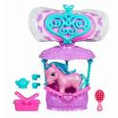
Monica: You're mother killed herself!
Phoebe: She was a drug dealer!
Ross: Well, anyway, it was a good thing Phoebe knew him, because (menacingly) I was about to do some serious damage!
menacingly adv.威胁地
Phoebe: (laughing) Okay...
Monica: Well, this must've brought back some really bad memories for you, Ross.
Phoebe: Why?
Monica: Well, Ross was mugged as a kid.
Phoebe: (worried) You were?
Ross: Yeah, it was pretty traumatic. I was outside St. Marc's Comics...you know, I-I-I was just there minding my own business, you know, seeing what kinda trouble Spiderman got into that week-
traumatic adj.创伤(性)的/mind vt.专心于 从事
St. Mark's Comics
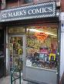
Monica: (coughing) Wonderwoman!
Wonder Woman is a fictional DC Comics superheroine created by William Moulton Marston. Two strong women, his wife Elizabeth Holloway Marston and Olive Byrne, a mutual lover,[1] served as exemplars for the character and greatly influenced her creation.[2] Wonder Woman first appeared in All Star Comics #8 (Dec. 1941). She is among the first — and most famous — comic book superheroines, and is a founding member of the Justice League. In addition to comic books, the character was featured in the popular 1975 to 1979 television adaptation starring Lynda Carter, as well as the Super Friends and Justice League animated series. A 2009 motion picture adaptation has been announced.
Ross: Anyway, I was heading towards this bakery, you know, to pick up a couple of dozen Linzer tortes for someone...(He looks at Monica) ...when outta nowhere this thug with a pipe jumps out and says: "Gimme your money, punk!"

torte n.德国果子奶油蛋糕/thug n.暴徒/pipe n.管

Linzer torte
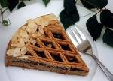
Phoebe: (shocked) Oh my god...
Ross: I know! And-and the worst part was they took my backpack which had all the original artwork I had done for my own comic book: "Science Boy"

backpack n.背包/ comic book n.连环漫画册
Monica: Oh yeah! What was his superpower again?
Ross: A superhuman thirst for knowledge.
superman n.超人/thirst for v.渴望 热望
Monica: That's it.
Ross: Well, I-I better get to class (He stands up) Are there any more of your friends I should look out for on my way, Phoebe?
look out for v.留心
Phoebe: No...actually, you might wanna stay away from Jane street...that's where Stabby Joe works.
Jane street
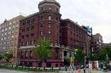
(Ross leaves Central Perk.)
Phoebe: Okay, I think we have a problem here.
Monica: What?
Phoebe: Well, uhm, back in my mugging days, you know, I, uhm, I worked St. Marc's Comics.
Monica: Yeah?
Phoebe: Well, a pipe was my weapon of choice and, uhm, pre-teen comic book nerds were my meat.
of choice adj.精选的 特别的/preteen adj.接近青春期的 13岁以下的
Monica: So?
Phoebe: Well, there was this one kid who had a sticker on his backpack that said-
sticker n.贴纸
Phoebe and Monica: "Geology rocks!"
Monica: Oh my god!
Phoebe: I know...I mugged Ross!
[Scene: Audition room, the producers and Lennart are waiting for Joey]
Receptionist: You're late!
Joey: (entering) I know, I'm sorry, but can I just have a quick second to run to the bathroom?
Receptionist: No, Lennart doesn't wait!
Joey: But I'm bursting with Yoo-hoo!
burst with v.突然发生/yoo-hoo int.为引起处的人注意时的叫声
Lennart: (spotting Joey) Joey! Here we go. Let's go very quickly!
spot v.发现
Joey: Actually, I really need...
Lennart: (interrupting) We must go now, quickly, please.
Joey: Yes...ahahaaa (He seems to be in pain)
Lennart: Ready? "What the hell are you still doing here?"
Joey: (walking on the spot) "I think you know!"
Lennart: "Oh, you sick bastard!"
Joey: "I am what you made me! You know what?"
Lennart: "What?"
Joey: "I could go right now."
Lennart: "Then go, go!"
Joey: (urgent) "I, oh, I can't. I want to, but I can't!"
Lennart: Cut! That was good. (He turns to the producers) That was very good. You did everything I asked for.
Joey: (disbelieving) I did?
Lennart: Yes. Plus...what you've got that...I don't know what you've got going...this squirmy quality that you bring into the character that I couldn't've even imagined. Wow, hey, here's what we gonna do: come back tomorrow for the final callbacks with the backers, do all of this what you've got going now, but – you know what? – more, more. Can you do that?

squirmy adj.扭曲的 蠕动的[eg: The only other horror of the barber business is squirmy kids]

Joey: Sure, yeah. I don't have time to say thank you because I really gotta go. (He grabs his jacket and limps out of the room)
limp vi.一瘸一拐地走 跛行
Lennart: (watching Joey leave) Look at that: still in character, I like it...I plant seeds, I can't explain.
be in character 入戏
[Scene: Monica and Chandler's Apartment, Chandler sits on the couch as Monica and Rachel enter]
Monica: Hey!
Chandler: Hey!
Monica: What are you doing?
Chandler: Putting on the sneakers...thought I'd get into a younger mindset, you know, to see if it sparked anything...
mindset n.心态[eg: I can't take their mindset anymore]/spark vt.激励 鼓舞[eg: It was this incident that sparked her interest in politics]
Rachel: Oh, anything yet?
Chandler: Yes, how's this: They're so uncomfortable it's like getting kicked in the nuts for your feet!
nut n.<美粗>睾丸
(At that moment, Joey opens the door)
Joey: (entering) Hey!
All: Hey!
(Joey heads straight for the fridge, takes all the beverage cans and is about to leave the apartment)
Joey: Probably wanna know what I'm doing…?
Monica: No, that seems about right.
Joey: Yesterday at my audition, I really had to pee, and apparently, having to pee makes me a really good actor. I got a call-back, so I'm drinking everything. Oh, by the way, that egg nog in our fridge was great!

Eggnog (or egg nog) is a sweetened dairy-based beverage made with milk, cream, sugar, beaten eggs (which gives it a frothy[adj.多泡的] texture), and flavoured with ground cinnamon(n.肉桂) and nutmeg(n.肉豆蔻); alcoholic versions also exist with the addition of various liquors, such as rum, brandy, or whisky. Eggnog is popular in North America. Eggnog is associated with winter celebrations such as Christmas and New Year's. Commercial, non-alcoholic eggnog is available around Christmas time and the winter holidays in North American grocery stores and this variant is available all year round in Australian stores. While the origins of eggnog are debated, it may have originated from posset[n.牛乳酒] (a medieval European beverage made with hot milk).


Rachel: Joey, that was formula.
formula<美>配制成的婴儿奶粉或奶水[eg: If you are not planning on breastfeeding, you have to decide on a formula]
Joey: We gotta get more of that. (He leaves the apartment)
Chandler: (sitting on the couch) You know what...these aren't half bad! (to Rachel) You should suggest something like these to Ralph Lauren.
not half bad 不错 不赖
Rachel: Okay, first of all, that's stupid and second of all, I'm not allowed to talk to Ralph.
Chandler: Alright (He stands wearing the sneakers on) I feel younger already!
(He trips and falls hard on his back)
Chandler: (on the floor) yeah, I think I broke my hip.
[Scene: Central Perk, Phoebe is there drinking coffee and Ross is about to enter]
Phoebe: (spotting Ross) Hey, you!
Ross: Hey!
Phoebe: Hey, how was class?
Ross: No one ever asked me that, what's wrong?
Phoebe: Nothing, I really wanna know.
Ross: Oh...(He looks positively surprised) Well, uhm, there was actually a rather lively discussion about the Pleistocene...
lively adj.热烈的/Pleistocene n.<地>更新世 洪积世
Phoebe: (interrupting) Alright, nothing is worth this. Uhm, I have a confession to make...uhm, okay, you know, that girl that mugged you when you were a kid...
Ross: (disbelieving.) Wh-What are you talking about? It wasn't a girl. It was this huge dude.He had a pitchfork and a sword.
pitchfork n.干草叉
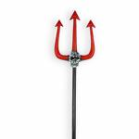
Phoebe: You don't have to lie anymore, Ross, I know that it was a fourteen year-old girl.
Ross: No, it wasn't.
Phoebe: Yes, it was.
Ross: No, it wasn't. You don't think I would've defended myself against a fourteen year-old...
Phoebe: (interrupting, pinching his ear) "Gimme your money, punk!"
Ross: (shocked) Oh my god, it was you! I can't believe it, you...you mugged me?
Phoebe: (apologetic) Yeah, and I'm so, so sorry, Ross, I'm sorry, but, you know, if you think about it, it's kinda neat. (She smiles at him, but he doesn't understand) I mean, well, it's just that I've always felt kinda like an outsider, you know, the rest of you have these connections that go way back and, you know, now, you and I have...have a great one!

apologetic adj.道歉的 认错的[eg: She was apologetic for not keeping her promise]/think about v.回想/neat<俚> wonderful；terrific；cool/outsider n.局外人[eg:To an outsider this looks like an idyllic(adj.田园式的) life]

Ross: It's not the best!
Phoebe: I know, I'm sorry, please forgive me. I don't know what to say...
Ross: There's nothing you can say. That was the most humiliating thing that ever happened to me.
Phoebe: Really? Even more humiliating than...
Ross: (interrupting) Hey, let's not do this!
(He picks up his briefcase and walks out of the door, leaving Phoebe behind)
[Scene: Chandler's new workplace, we are witnessing a presentation of a fellow intern]
Intern: ...and then, at the end of the commercial, the girls get out of the hot tub and start making out with each other!
hot tub

Boss: (ironic) That's interesting! Just one thought: You didn't mention the shoes. Who's next? (Chandler raises his hand) Chandler...
Chandler: Okay...(He stands up) You start on the image of a guy putting on the shoes. He's about my age...
Intern: (snorting) Your age?
snort vt.轻蔑(或愤怒)地哼[eg: She began to show signs of impatience and snorted audibly]

Chandler: A-huh. So he's rolling down the street and he starts to lose control, you know...maybe he falls...maybe he hurts himself. Just then, a kid comes flying by wearing the shoes. He jumps over the old guy and laughs, and the line reads: "Not suitable for adults!"

just then adv.就在这时候
Boss: Chandler, that's great!
Chandler: Oh, thank you, sir...or man-who's-two-years-younger-than-me (He sits down again)
Boss: You see? That has a clear selling point. It appeals to our key demographic, it's…. (enthusiastic) How did you come up with that?

selling point n.卖点/demographic n.目标客户群

Chandler: (over-enthusiastic) I don't know, I don' I don' know! I was just trying to get into a young mindset, you know, and it just started to flow.
Boss: That is great. Good work!
Chandler. Thank you.
Boss: See all of you tomorrow. (He leaves)
(Chandler stands up and walks out the room with a cane.)
cane n.手杖 拐杖[eg: Grandpa takes along a cane when he goes out for a walk]
Chandler: The cold weather hurts my hip!
[Scene: Central Perk, Ross sits in a chair as Phoebe enters]
Phoebe: Hey, Ross! (He lowers his newspaper and scowls at her) I know you're still mad at me, but can I just talk to you for a second?

scowl vi.对...沉下脸[eg: The father scowled his disappointment at his son]
Ross: Sure, go ahead. Whoops, sorry, sure, go ahead. (He raises his hands as if being mugged)
Phoebe: I just really wanted to apologize again and...and also show you something I think you'll find very exciting.
(She puts a box on her lap, labelled "crap from the street".)
Ross: (faking enthusiasm) Oh my god, crap from the street? (She smiles excitedly, but Ross just turns back to his newspaper)
Phoebe: Look, Ross, in this box are all the things I got from mugging that I thought were too special to sell...or smoke. (Ross looks at her in astonishment) Anyway, I was looking through it and I found "Science Boy" (She holds up some sheets of paper and hands them to Ross)

Ross: Oh my god. (He sighs) I never thought I'd see this again. (He browses through the pages) It's all here. What made you save it all these years?
Phoebe: I can't say, I just thought it was really good...and...maybe would be worth something some day.
Ross: You really thought "Science Boy" was worth saving!
Phoebe: Yeah...but you should know, I also have a jar of vaseline and a cat skull in here.
vaseline n.凡士林

Ross: Still...this is amazing...Oh my god, thank you, Phoebe.
Phoebe: You're welcome. And thank you for "Science Boy". I learned a lot from him.
Ross: You're welcome. Wait a minute. Did you add something to him?
Phoebe: Oh, yeah. Well. You see, the way you drew him,there was no way he was ever gonna get Gravity Girl. He looked like a Ken doll in those tights.(Ross writes something) What's that? What are you...?
tights n.贴身衬衣
Ken (lesser known full name Ken Carson) is a toy doll in Mattel's Barbie line of fashion dolls.
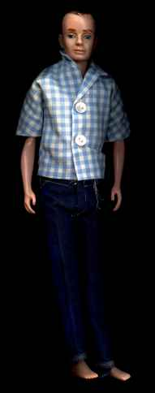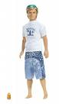
Ross: Is that a beaker or are you happy to see me?
beaker n.有倾口的烧杯
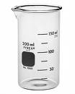
Phoebe: I don't get it.
[Scene: Audition room, Joey and Lennart are rehearsing]
Joey: (hoping frantically on the spot, screaming) "I need an answer!"
Lennart: "I-I-I can't tell you somethin' I don't know."
Joey: "You know!"
Lennart: "I don't know!"
Joey: "I need an answer now!"
Lennart: "Alright, here, you want an answer...the answer...is…"
(He pauses while Joey struggles to avoid wetting his pants)
Joey: (screaming) Oh!
Lennart: "She never loved me, she only loved you."
Joey: "You knew this all along and you never told me? You never told me? I can never forgive you, I can never forgive myself, I have nothing to live for – Bang – End Scene!"
all along adv.一直
Lennart: Absolutely amazing! (The producers applaud Joey) The part is yours.
Joey: (in pain) Oh thanks, thanks! Now, I really have to get...
Lennart: Wa-wa-wa-wait! Congratulations! You did it! You did it! (He hugs Joey) You can relax now. Yeah.
(Joey relaxes and wets his pants while hugging Lennart)
Closing Credits
[Scene: Monica and Chandler's Apartment, Monica sits at the table reading the mail]
Monica: Wow, that's a big cable bill! Huh, you don't have a job, but you have no problem ordering porn...on a Saturday afternoon?! (shocked) I was in the house!
Ross: (entering) Hey, uhm, Phoebe didn't by any chance mention that...
by any chance adv.万一 也许[eg: If by any chance somebody calls me, ask him to leave a message]
Monica: ...that she was the huge guy that mugged you? Yeah.
Ross: I see. You didn't happen to tell...
Monica: ...everybody we know? Yeah.
Ross: Great. Thanks! (He leaves)
END

